Dear Candidate,

**SENIOR SOFTWARE ENGINEER**

Thank you for your interest in joining the Erideon Group.

To help us find out more about you, we would like to hear your thoughts on some topics we have raised in this questionnaire. Please take a few moments to provide your feedback on the questions below, and then return this document via reply email.

Thank you.

With Best Regards,

Erideon Careers Team  
Tel: (+65) 66808271  
Fax: (+65) 66808273   
Email: careers@erideon.com   
Web: www.erideon.com

**Summary**

Name: Myat Thu (Frank) Age: 30

Current Location:  Gender:

Work Permit Status:  Experience: 10.0 (years)

Latest Employer: Willowglen services pte ltd

Latest Position: Software Engineer

Highest Qualification:  Field: BA Geography

Availability:  Expected Salary: 4000 (SGD)

**General Questions**

1. In one word describe your greatest strength.
2. What two or three things are most important to you in your job?
3. What responsibilities did you like most and least in your last job? Why?
4. Describe one example where your actions led to improved quality of your organisation’s product or service.
5. What do you see yourself doing five years from now?
6. What makes you stand out / why should we hire you?

**Technical Questions**

**Web**

1. Create a HTML page with a list of items from which users can choose one at a time. Items in the list must be horizontally centred within the list, and the list itself must be centred both horizontally and vertically on the page. When any item in the list is moused over, it is highlighted. When item is clicked, it is shown in bold and a prompt is raised to display the item’s content. When a new item is clicked, formatting from the previous item must be removed first. Please see below for illustration, and the look and feel that should be matched by your CSS. Cross-browser compatibility with minimally Internet Explorer and Chrome browsers should be maintained. Please provide your answer as a single HTML file.

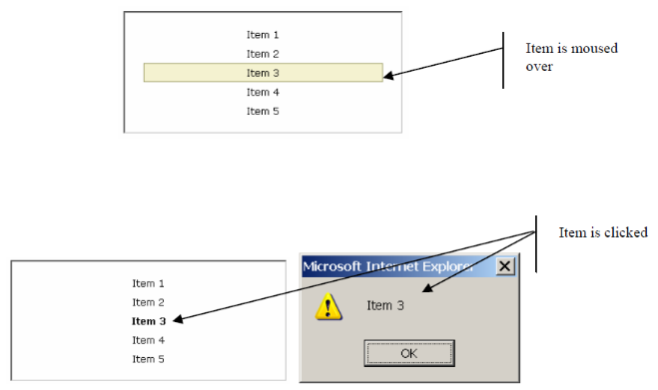

**T-SQL**

1. Insert 100 rows into the following table:

CREATE TABLE #TEST1 (TEST_ID INT IDENTITY(1,1))

------------------------------------------------------------

-- Solution

------------------------------------------------------------

DECLARE @COUNTER AS INT

SET @COUNTER = 1

WHILE(@COUNTER <= 100)

BEGIN

INSERT INTO #TEST1 DEFAULT VALUES

SET @COUNTER = @COUNTER + 1

END

SELECT * FROM #TEST1

1. Write SELECT query to list latest record for each [Id]:

CREATE TABLE #TEST2 ([Id] VARCHAR(10), [Data] VARCHAR(250), [Date] SMALLDATETIME)

INSERT INTO #TEST2 VALUES

('A', 'abc', '2016-10-01'),

('A', 'def', '2015-05-20'),

('B', 'xyz', '2014-05-20'),

('B', 'uvw', '2016-10-01'),

('B', 'rst', '2015-10-01')

------------------------------------------------------------

-- 1st Solution

------------------------------------------------------------

SELECT * FROM #TEST2

WHERE [Date] IN (SELECT MAX(#TEST2.Date) FROM #TEST2 GROUP BY #TEST2.Id)

------------------------------------------------------------

-- 2st Solution

------------------------------------------------------------

SELECT *

FROM (SELECT *, ROW_NUMBER()

OVER(PARTITION BY Id ORDER BY Date DESC) AS RowNumber

FROM #TEST2) AS _TEST2

WHERE RowNumber = 1

1. Write a single SELECT statement to list all unique values of attribute “z”:

CREATE TABLE #TEST3 ([Data] XML)

INSERT INTO #TEST3 VALUES

('<r><a z="1" /><a z="2" /></r>'),

('<r><b z="2" /><b z="3" /></r>'),

('<r><c z="3"><c z="4" /></c></r>')

------------------------------------------------------------

-- 1st Solution

------------------------------------------------------------

SELECT SecondLevel_Tag.value('@z', 'NVARCHAR(MAX)') AS Z_Value

FROM #TEST3

CROSS APPLY Data.nodes('/r/*') XMLTag(SecondLevel_Tag)

UNION ALL

SELECT ThirdLevel_Tag.value('@z', 'NVARCHAR(MAX)') AS Z_Value

FROM #TEST3

CROSS APPLY Data.nodes('/r/*/*') XMLTag(ThirdLevel_Tag)

------------------------------------------------------------

-- 2st Solution

------------------------------------------------------------

SELECT

XMLTag_SecondLevel.value('@z', 'NVARCHAR(MAX)') AS Z_Value_in_SecondLevelTag,

XMLTag_ThirdLevel.value('@z', 'NVARCHAR(MAX)') AS Z_Value_in_ThirdLevelTag

FROM

#TEST3 tbl_SecondLevelNode CROSS APPLY Data.nodes('/r/*') XMLTag_SecondLevel(XMLTag_SecondLevel),

#TEST3 tbl_ThirdLevelNode CROSS APPLY Data.nodes('/r/*/*') XMLTag_ThirdLevel(XMLTag_ThirdLevel)

1. Consider a table with an [Id] column as well as BIT columns named [A] to [E] and some initial values:

CREATE TABLE #TEST5 ([Id] INT, [A] BIT, [B] BIT, [C] BIT, [D] BIT, [E] BIT)

INSERT INTO #TEST5 ([Id], [A], [C], [E]) VALUES (1, 'true', 'false', 'true')

INSERT INTO #TEST5 ([Id], [A], [B], [C]) VALUES (2, 'true', 'true', 'true')

INSERT INTO #TEST5 ([Id], [C], [D], [E]) VALUES (1, 'false', 'false', 'true')

Create a procedure which will accept parameters ([Id] INT, [Column] CHAR (1)) and then invert the value in table #TEST5 for row matched by [Id] and column named [Column]. No change is made if existing value is NULL.

------------------------------------------------------------

-- Solution

------------------------------------------------------------

CREATE PROCEDURE BitInverter

(

@Id Int,

@ColumnName CHAR(1)

)AS

BEGIN

DECLARE @sql NVARCHAR(MAX)

SET @sql = N'UPDATE #TEST5 SET '+@ColumnName+' =

CASE WHEN '+@ColumnName+' IS NOT NULL

THEN '+@ColumnName+' ^ 1 END

WHERE Id = '+ CAST(@Id AS VARCHAR(255)) +''

EXEC sp_executesql @sql, N'@Id INT, @ColumnName CHAR(1)', @Id , @ColumnName

END

EXEC BitInverter 1 , 'A'

1. (Optional: This question is not mandatory, but a correct answer will be well regarded.)

Programmatically find the least number of hops needed to get from Id=1 to Id=15 using the grid provided below. For example, to get from Id=1 to Id=4 will require 2 hops - (1,3) followed by (3,4).

CREATE TABLE #TEST6 ([FromId] INT, [ToId] INT)

INSERT INTO #TEST6 VALUES

(1,2), (1,3), (3,4), (5,10), (5,6), (7,5), (1,7), (2,8), (8,9),

(9,11), (9,10), (10,12), (10,14), (12,13), (14,15)

**Coding**

1. What reasons require Refactoring of code?
2. How would you measure the quality of source code?

1. What do you feel is the most promising new technology in web / software development and why?